ARLas Calibration

Documentation of Calibration Routine for ARLas

Shawn S. Goodman

*October 18-22, 2019*

**Overview**

This document describes the procedure for calibrating the ER10X (Etymotic Research) probe-microphone system, as it is used with ARLas (Auditory Research Lab audio software; Goodman). Although the method is specifically for use with the ER10X, it might also be used, with modification, with other OAE hardware systems (e.g. ER10C, ER10B+). Modifications needed for these other systems are discussed briefly in the Discussion section. This tutorial is also geared toward calibration for animal experiments, specifically for guinea pigs, with a calibration frequency range from 0.2-32 kHz. For use with human subjects or other animals, further modifications may be needed, and these are also discussed in the Discussion section.

The calibration procedures consist of two main parts: 1) *coupler*, and 2) *in-situ*. The coupler calibration is done first. It uses standardized couplers to quantify key physical characteristics of the ER10X hardware. The in-situ (a Latin phrase meaning “on site” or “in position”) calibration refers to in-the-ear calibration done at the time of the actual experiment. In-situ calibration quantifies key physical characteristics of the particular system being recorded from. This system is typically the “ear” (specifically, the peripheral auditory system comprised of the canal, middle ear, and cochlea) of a human or non-human animal.

The *coupler* calibration procedure consists of three main parts: 1a) ER10X Thevenin source calibration, 1b) ER10X microphone calibration, 1c) verification of the calibration.

The *in-situ* calibration procedure consists of three main parts: 2a) Recording the response of the ear to a broadband chirp, 2b) creating a stimulus of the desired level(s), and 2c) applying appropriate corrections to the recorded OAEs.

**Required Hardware**

Modified Sound Delivery Tubes. The ER10X probe tube is a disposable, clear plastic cylinder. The cylinder has a central circular core surrounded by eight trapezoids. When attached to the probe, the central core of the probe tube connects to the microphone, and the trapezoids connect to the two loudspeakers. As provided by the manufacturer, both ends of the probe tube are cut flat at right angles to the long axis (Fig. 1, left panel). In this configuration, the sound outlet and microphone inlets lie in the same plane. As a result, evanescent waves make strong contributions to the measured microphone responses, causing calibration inaccuracies at standing wave nulls in the calibration tubes. In order to overcome this, the end of the probe tube should be beveled so that the sound from the loudspeakers exits the tube ahead of the microphone inlet. This reduces the evanescent wave contributions, allowing accurate calibrations at extended high frequencies. At the time of this writing, this must be done by hand for each tube. This is best accomplished by first attaching a new, flat probe tube to the probe and then cutting the tube tip using a razor blade. A magnification device is very helpful in this process. Figure 1 shows an example of a beveled probe tube, as well as a basic schematic of where the cuts should be made. Naturally, the cuts should be made as cleanly and as evenly as possible. It is nearly impossible to achieve a perfectly clean and even set of cuts when doing this by hand. Luckily, very good calibrations can still be achieved as long as this ideal is approximated to some extent. Because every cut tip will be unique, is important to calibrate each tip individually. *Every time a tip is replaced, a new Thevenin calibration should be done.*

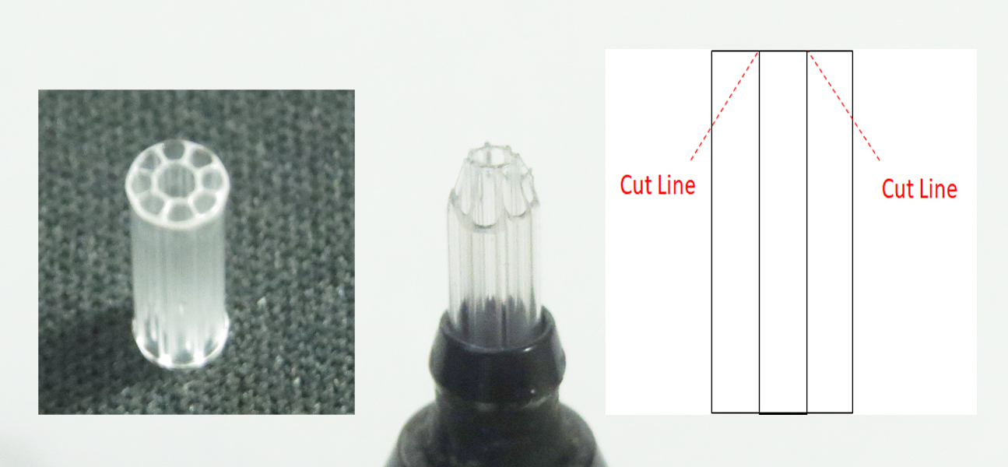

**Figure 1**. Beveling the tip of the probe tube. Left panel shows a sound delivery tube provided by the manufacturer. Center panel shows an attached delivery tube after cutting the edges with a razor blade. Note that the center core has not been cut. All of the trapezoids around the outside have been cut at approximately a 45-degree angle. Right panel shows a schematic of where the cuts should be made.

NOTE: A probe tube can potentially be reused many times before it needs to be replaced. When the probe tube becomes clogged or damaged, it should be replaced and a new calibration should be done. When replacing the plastic sound delivery tube, remove the old tube by grasping firmly and pulling out with a slight twisting motion. Some force will be required to do this. It is not usually possible to remove the tube without creating an indentation in the plastic tube, thereby ruining it for further use. When installing a new tube, place it into the entrance of the probe and press down. Be sure that it seats fully! Again, some force is required to seat the tube properly. There should be a “click” or “snap” as the tube seats itself. This is very important! Failure to seat the sound delivery tube will result in poor calibrations.

Hollow Ear Bar. The ear bar is a hollow plastic tube that functions as both a sound delivery system and a head-holding device in our guinea pig experiments (Fig. 2). The ear bar is 5.5 cm in total length. It has an outer diameter of 0.8 cm over most of its length. One end of the hollow ear bar is designed to attach to the ER10X probe tube. This end has a short metal tube with an inner diameter matching the outer diameter of the probe tube (0.3 cm). The ER10X probe tube is inserted into this end of the ear bar. The hollow portion of the ear bar is manufactured so that there are no discontinuities along the length. While the inner cavity is constant, the outer diameter of the ear bar is beveled, so that it tapers over the last 1.1 cm until it meets the 0.3 cm opening. The tapered opening is placed into the bony portion of the guinea pig ear canal when performing experiments. This leaves an additional small cavity, with an estimated length of 1 mm.

The length of the ear bar introduces a significant time delay in the delivery and recording of acoustic stimuli. Specifically, after subtracting the insertion depth of the probe tube into the ear bar (0.65 cm) and adding the length of the ear canal cavity (0.5 cm), there is 5.5 – 0.65 + 0.5 = 5.45 cm length for the sound to travel before reaching either the eardrum. Assuming that the speed of sound in air is approximately 34616 cm/s, (at 25 degrees Celsius at sea level) this results in a travel time of 5.45/34616 = 157.4 s. This delay will be seen in both coupler and in-situ recordings, and it must be accounted for carefully. From the perspective of the ER10X microphone, if an acoustic impulse is presented, there will be an initial impulse recorded, which is the incident, forward travelling pressure wave. The sound will travel down to the eardrum (or reference mic) and be partially reflected. The reflected energy will travel back down the ear bar, reaching the ER10X microphone after a delay of 157.4 x 2 = 314.8 s.

It is important to realize that these pressures recorded by the ER10X are *not* the same pressures that the eardrum/reference microphone experiences, neither in terms of magnitude nor in terms of time/phase. The pressures experienced by the eardrum will delayed by 157.4 s, and the pressure magnitudes will be slightly reduced at higher frequencies due to viscothermal losses incurred by sound travelling the length of the ear bar.

It is the purpose of the Thevenin calibration to enable the use of the ER10X microphone to estimate the pressures that are actually experienced by the eardrum. Although this can be done accurately even when there are large reflections within the ear bar, such reflections are generally not ideal. Consider, for example, an experiment in which researchers wish to examine an animal’s responses (either acoustic or electrical) to a short acoustic click. If the stimulus actually consists of an initial click, followed by a series of substantial reflected clicks, then the experiment no longer examines responses to a single click stimulus. Acoustic reflections inside of the ear bar cannot be easily eliminated. They may be reduced by introducing acoustic damping material into the ear bar. Placing a small amount of fiberglass along the length of the ear bar resulted in a reduction of the first reflection by approximately 6 dB. However, the incident forward energy was also reduced, and this was deemed counterproductive, especially at the higher frequencies where output amplitudes are lower to begin with. Further a close look at the waveforms recorded inside the ear bar *without* damping material suggests that damping material is not needed (Fig. 3). When properly calibrated for flat forward pressure level (FPL), only a single impulse is seen at the reference microphone, which is situated where the eardrum would be (Fig. 3, bottom panel). The majority of the impulse energy is contained within a 0.5 ms time window, and the entirety of the impulse energy is contained within a 1 ms time window. There is no evidence of any internal reflections occurring later in time. This means that using the calibration method described in this paper, a single, short impulse can be successfully delivered to the eardrum, with no damping needed inside the hollow ear bar.

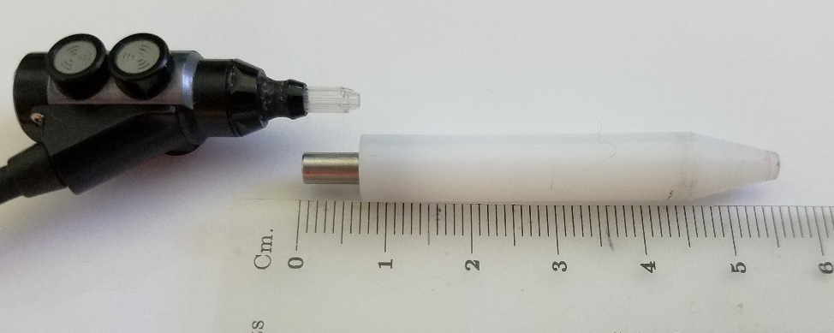

**Figure 2**. Hollow ear bar, shown with the ER10X probe. The probe tube slides inside the metal cylinder on the left side of the ear bar.

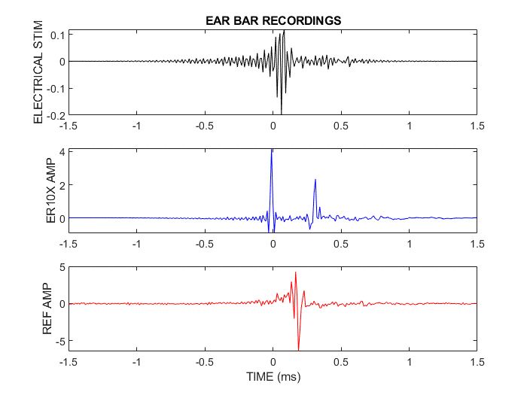

**Figure 3**. Acoustic recordings made in the hollow ear bar. The stimulus has been created to give a spectrally flat forward pressure level (FPL) response from 0.2-32 kHz. Top panel shows the electrical stimulus waveform (black) delivered to an ER10X loudspeaker. Middle panel shows the recording made by the ER10X microphone (blue) located at the proximal end of the ear bar. Time zero has been arbitrarily defined near the first peak of this recorded waveform. A second peak occurs near the expected round-trip delay value of 314 s. The reflected peak has been reduced by approximately half (6 dB), relative to the initial incident peak. There are no additional reflections to be seen. This may be partly due to the electrical stimulus continuing into the time where the reflected peak is seen. If created appropriately, the electrical stimulus could drive the loudspeaker diaphragm in such as way so as to cancel out some of the pressure that would otherwise return to the reference microphone at the distal end of the ear bar. The lack of additional reflections may also be due to the ER10X probe having relatively low reflectivity. The strong first reflection suggests that in contrast, the reference condenser microphone has relatively high reflectivity. Bottom panel shows the recording made by the reference condenser microphone (red) positioned at the distal end of the ear bar. Notice that the impulse arrives at the reference microphone with a delay near the expected one-way delay value of 157 s.

Finally, it is worth noting that the use of long (relative to a guinea pig ear canal) ear bar may actually impart an advantage when it comes to monitoring sound pressures delivered over the course of an experiment. As shown in the middle panel of Fig. 3, the forward incident pressure recorded by the ER10X microphone is separated from any cochlear influence by approximately 314 s. This means that this early peak in the recorded acoustic waveform can be monitored to ensure that no changes occur during the experiment. This is not possible when very short ear canal distances are involved, since there is a lack of sufficient separation between delivered incident pressure and reflected sound from the eardrum, as well as (potentially) reflected sound from the very basal of the cochlea (i.e. early OAE energy).

Thevenin Calibration Tubes. In addition to the OAE probe-microphone system (e.g. ER10X), appropriate couplers are needed. For the Thevenin source calibration (1a), a set of five tubes is needed. The tubes should be made of metal, preferably stainless steel. Brass can also be used. Whatever metal is chosen, it should not be soft and it should not easily corrode. The tubes should be open on one end and closed on the other. The tubes should be the same size diameter as the probe tube (0.3 cm for the ER10X). The lengths of the tubes should be the following values: 2.9, 3.6, 4.15, 5.2, and 6.9 cm. The tubes should be perfectly smooth along their length, and the closed ends should be perfectly flat. At the time of this writing, the author is unaware of a commercial source for these, and they must be custom built. Figure 4 shows a set of Thevenin calibration tubes.

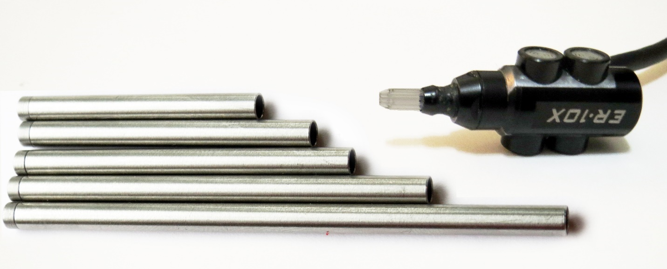

**Figure 4**. Set of stainless Thevenin calibration tubes next to an ER10X probe. Tubes are 0.3 cm in diameter and 2.9, 3.6, 4.15, 5.2, and 6.9 cm in length. Note the beveled tip of the probe tube on the ER10X, as discussed previously.

Reference Coupler with Refence Microphone. A reference coupler and microphone are needed for calculating an ER10X microphone correction and for verifying the Thevenin calibration. These steps are a critical part of the calibration process. The ER10X microphone is only flat at frequencies below 10 kHz. At higher frequencies, it tends to be too sensitive. Without applying a microphone correction, the measured sound pressure levels will register up to 10-15 dB higher than they actually are. At the time of this writing, the manufacturer does not provide a microphone correction. Note that when the microphone setting on the ER10X system is set to “flat”, this simply means that no correction has been applied. *It does not mean that the microphone sensitivity is flat.* Accurate microphone calibration at extended high frequencies using currently available methods can be difficult. A robust method has been described by Siegel (XXX) and by Rashetswane and Neely (XXXX). However, this method requires the use of an additional probe microphone and a special coupler. Particularly problematic is that this method requires use of a very thin probe, which can be considered acoustically transparent when placed directly in front of a reference microphone. Generally speaking, such probe microphone systems are unsuitable for calibration of extended high frequencies. The viscothermal losses through such very thin probes are high. Further, commercially available probe tube systems, such as the ER7, have poor microphone sensitivity above 10 kHz. In our lab, we have developed a convenient method that utilizes a previously-obtained Thevenin source calibration. The method requires only a single condensor reference microphone. In this method, the same coupler is used both to obtain the microphone correction and to verify the Thevenin source calibration.

Verifying the Thevenin source calibration is also an important step in the calibration process. When the Thevenin calibration is performed, an error value () is generated. A low error value is consistent with a good calibration, but it does not guarantee it. The real proof of a good calibration is the ability to accurately predict the sound pressure measured by a reference microphone placed at the opposite end of a reference coupler. When this has been demonstrated, the *coupler* portion of the calibration process is complete, and these coupler calibrations may subsequently be used as part of the *in-situ* calibration in experiments.

The reference coupler described here is a custom-built brass cylinder. One end is fashioned to couple to the hollow ear bar. The other end of the brass coupler is made to receive a 1/8th-inch condenser (reference) microphone. The microphone can either be a type that requires a polarization voltage or it can be a pre-polarized type. Note that the holes in the two ends of the brass coupler are different sizes. The larger hole is for the ear bar and the smaller is for the reference microphone. There are rubber O-rings that sit on a ledge around each hole. The rings are not attached and can fall out easily, so be careful not to lose them. The brass coupler assembly is shown in Figures 5 and 6. One final note of practical importance: When inserting either the ear bar or the microphone into the coupler, be sure to remove the end caps first. This is primarily because the O-rings easily become dislodged from the shelves on which they sit. Damage could result if the O-rings are not seated properly and force is applied during insertion.

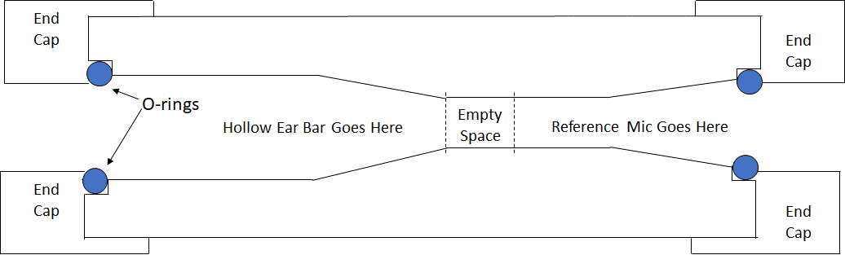

**Figure 5**. Reference Coupler, rough schematic view (not to scale).

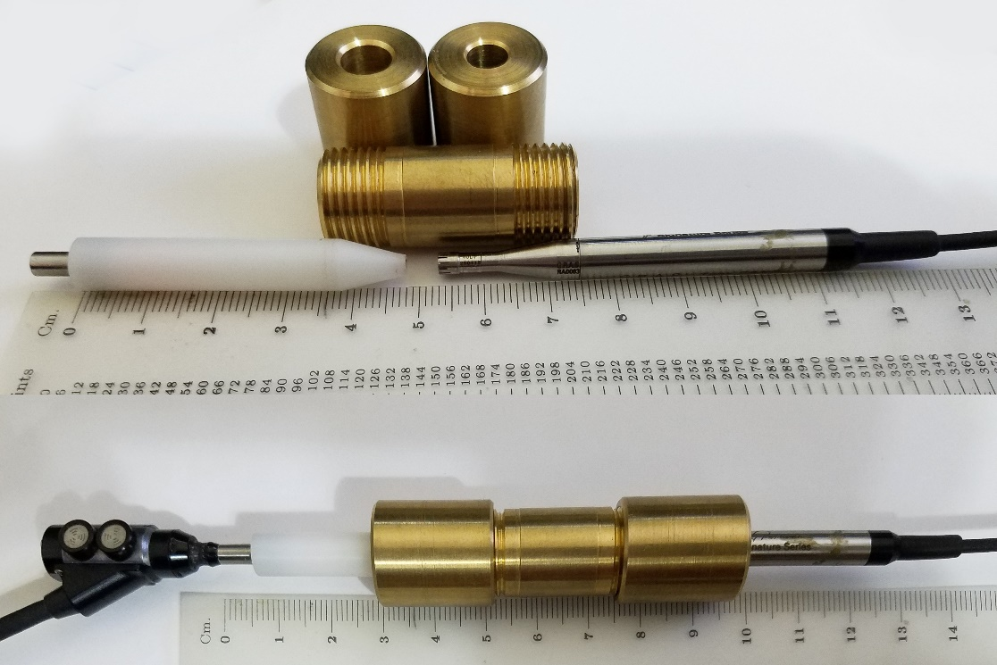

**Figure 6**. Reference Coupler. Top panel shows the central core of the brass cylinder next to the ear bar (below on the left side) and reference microphone (below on the right side). The cylinder has end caps (shown above the cylinder), which screw on to help hold the ear bar and microphone in place. In this figure, the ear bar and microphone are set facing each other such that the distance between them is the same as it is when they are placed inside the coupler. This distance is 0.5 cm, the same approximate distance between the end of the ear bar and the eardrum when placed in a guinea pig ear canal (pinna resected). Bottom panel shows the reference coupler when assembled and ready for use.

**Required Software Updates**

Knowing the exact system delay is critical to an accurate Thevenin calibration. Here, the “system delay” refers to both hardware and software components of the data collection system. In the software, it is important to compensate for the delay a signal incurs as it is sent by the computer to the Digital-to-Analog converter, though the sound card, through the hardware to the loudspeaker, to the microphone, and finally back the Analog-to-Digital converter.

Previous versions of the ARLas software have measured system delay using a direct input-to-output electrical connection on the sound card. This has the advantage of repeatability and good signal to noise ratio. This delay varies based on the computer hardware, operating system, and sound card. This method does not depend on the sound delivery system used. For example, the system delay would be considered the same whether an ER10X or an ER10C was being used to present and record sound.

As might be expected, a small additional delay results from passing the signal through the sound delivery system. For most applications, this difference, on the order of 100-200 s, is trivial. However, for calibrating extended high frequencies with Thevenin source methods, failure to account for this additional delay results in poor calibrations. It is therefore critical to calculate system delay so that it includes the delay of the probe microphone system. If you are running a version of ARLas on which system delay was calculated using a direct electrical connection, *before you proceed with calibration, you must re-calculate system delay using the acoustic measurement system that you will be using*. Instructions for doing this are given in the next paragraphs.

When you start ARLas, click on the Initialize button as usual, and load the initialization file that you usually use. Then load the experiment file “ARLas_getDelay.m”, which should be located in the experiments\SETUP directory. Before you press the Run button, open the experiment file and make sure that the output and input channels are correctly specified. If you are unsure about what values to use, look in the hardwareSetup file located in the sysConfigs folder. Finally, put the ER10X probe that you are using into the reference coupler, as shown in the bottom panel of Fig. 6. Press play. A dialog box will tell you that a direct electrical connection is recommended. Ignore this and continue. ARLas will play and record 10 clicks, calculate a delay value, and report this to you. Write the value down.

Once again, click on the Initialize button and load the initialization file that you usually use. Now write the new value in the System Delay box on the top right of the GUI. Click the gray Save Configuration button on the lower right. Give this configuration a new name. This will be the config file you use whenever you are using this calibration method. You can use it other times, as well. It is probably best to always use the same config file, regardless.

Compare the old and new values. The delay value obtained using the acoustic delay should be slightly longer than the direct electrical connection. For example, on my machine, the direct value is 4203 samples and the new value is 4220. At a 96 kHz sampling rate, this difference is (4220-4203)/fs = 177 s.

**Calibration Procedure: *1) coupler***

Open the experiment file named ARLas_calibrationRoutine_DW10x.m This is the experiment file that manages the entire calibration procedure for part 1. At the top of this experiment file, you will see the following lines of code:

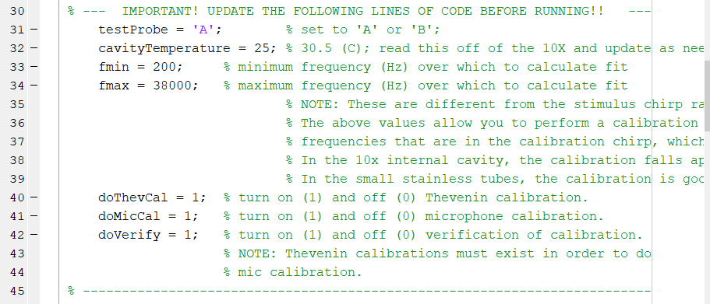

Update these lines, as necessary, before running the calibration. Choose probe A or B. Read the temperature for the probe you are calibrating from the front of the ER10X box. Leave the fmin and fmax values alone. We are calibrating up through 32 kHz, and we want to go past that value (to 38 kHz) in order to ensure good values out to 32. Leave the other switches (e.g. doThevCal) set to 1.

When you are ready to begin, press Run, and follow the directions on the screen. The first part of the calibration will have you put the probe into the Thevenin calibrations tubes of various length. When you do so, an air-tight seal is not necessary, nor recommended, as a small air leak is good for microphone. Do NOT use a rubber tip at the base of the cavities to create an air tight seal. This is not necessary and will result in poor calibration results.

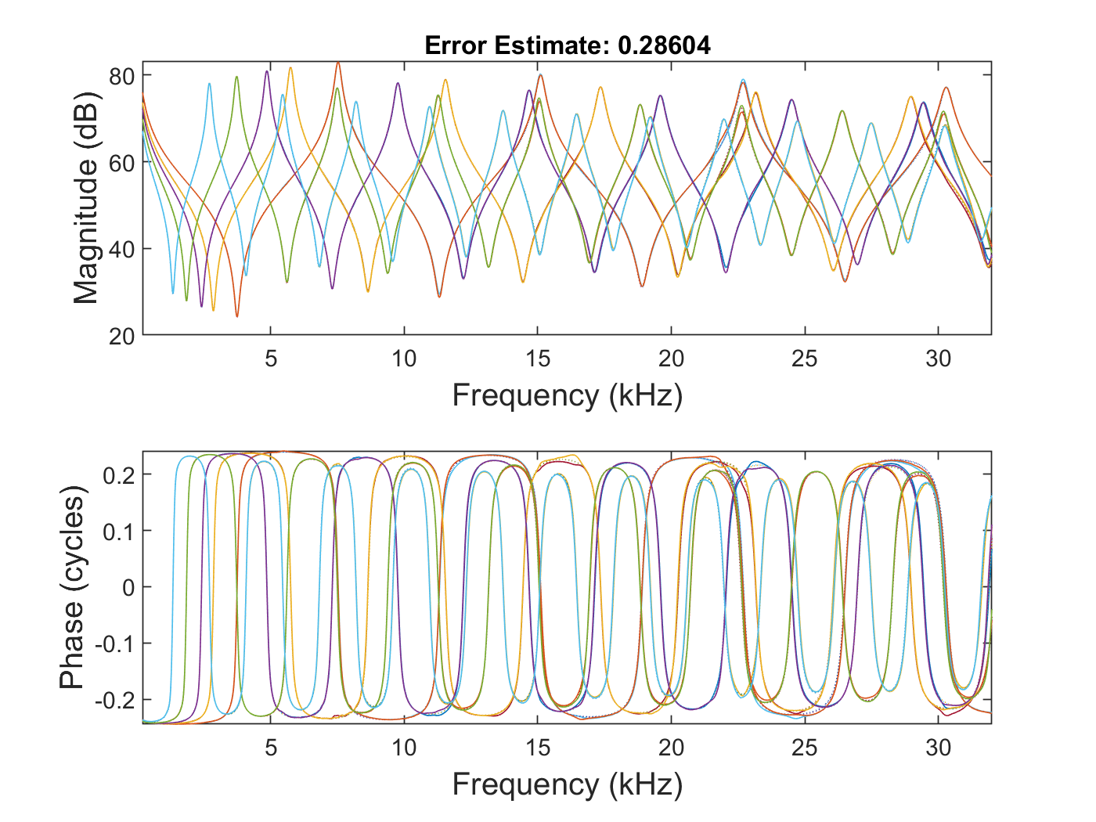

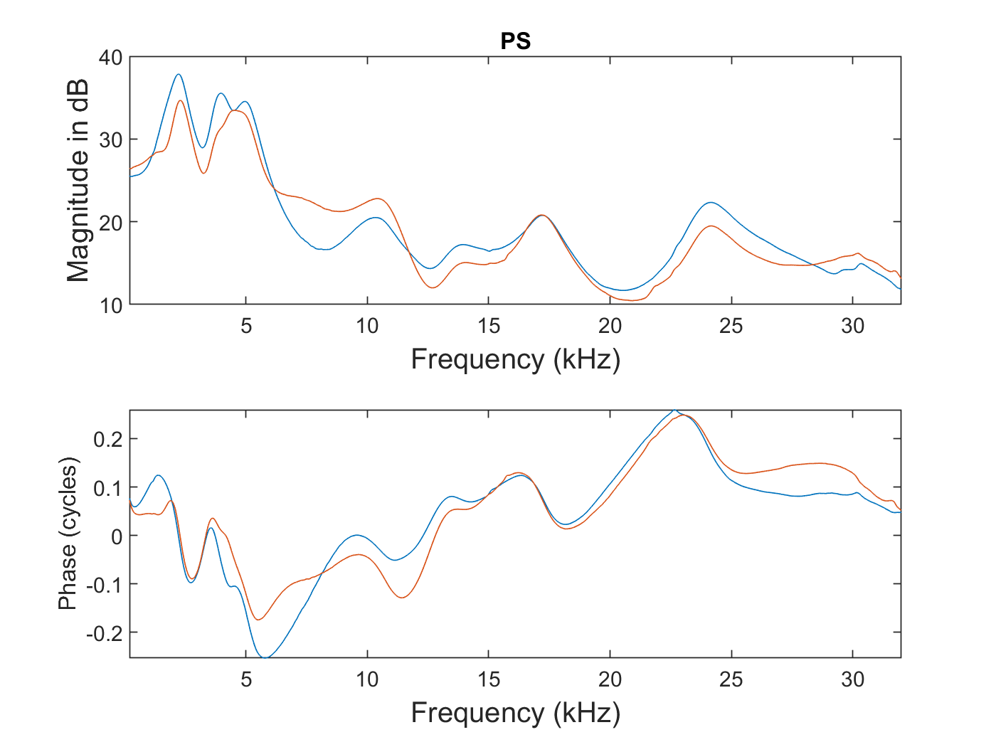

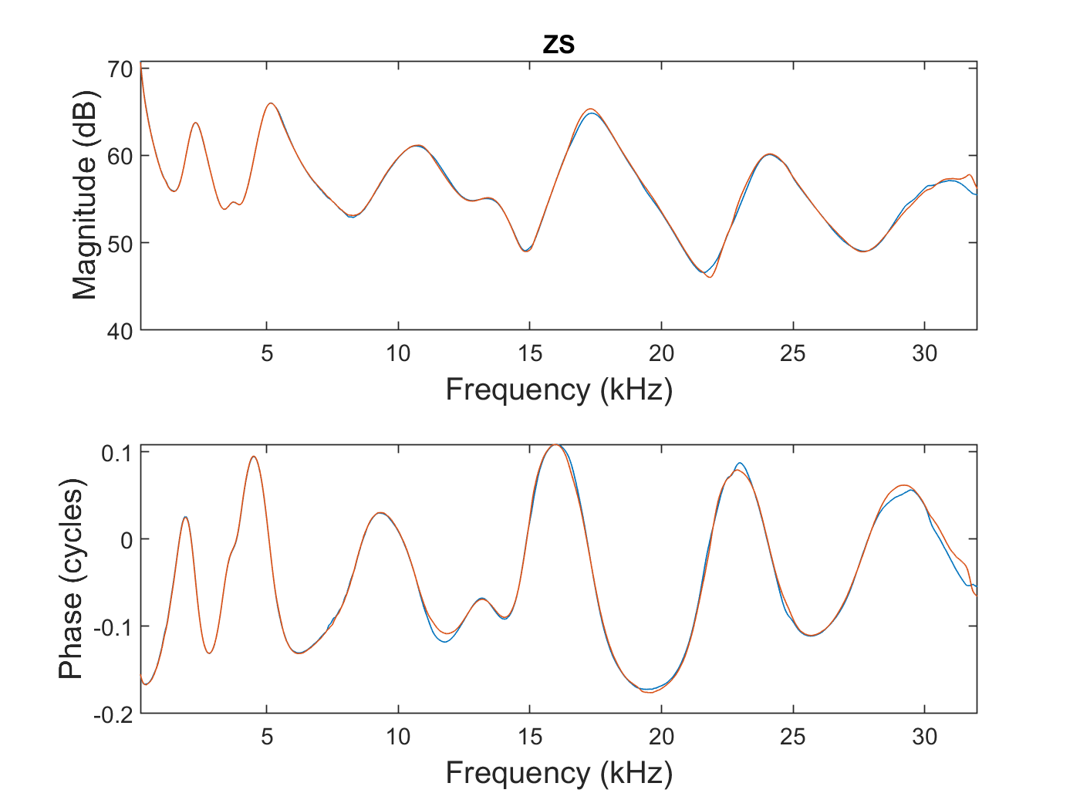

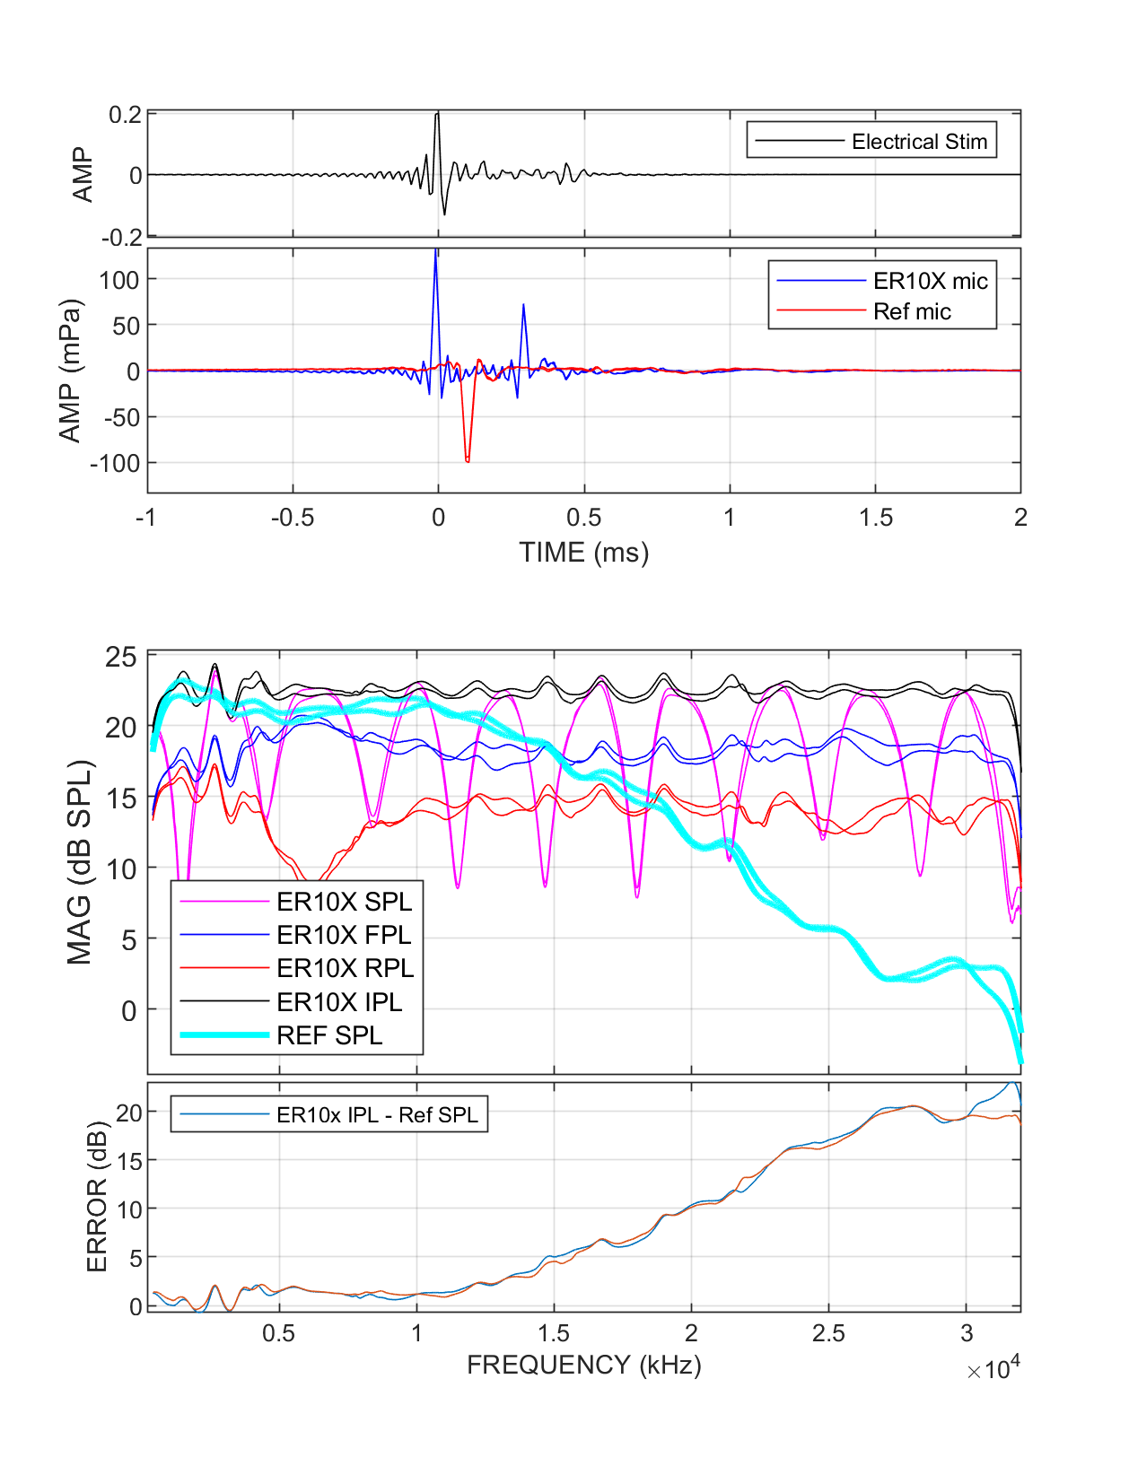

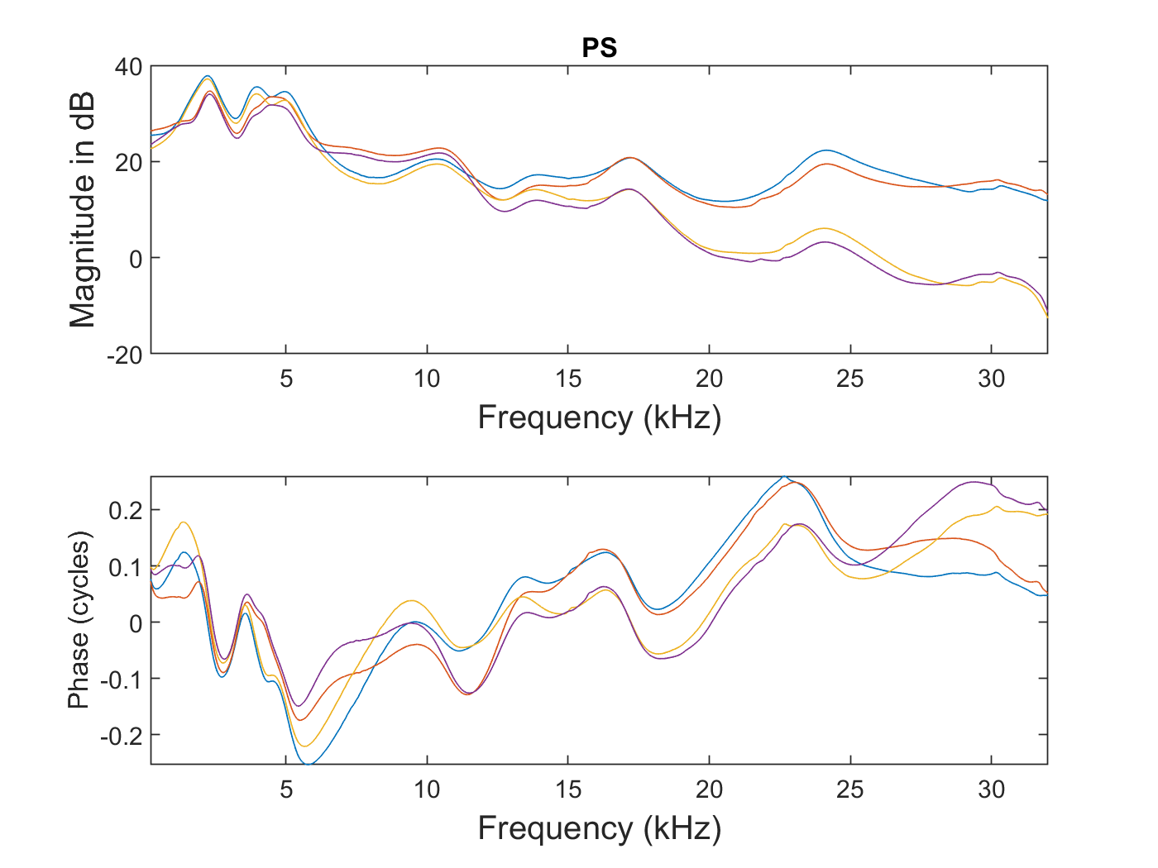

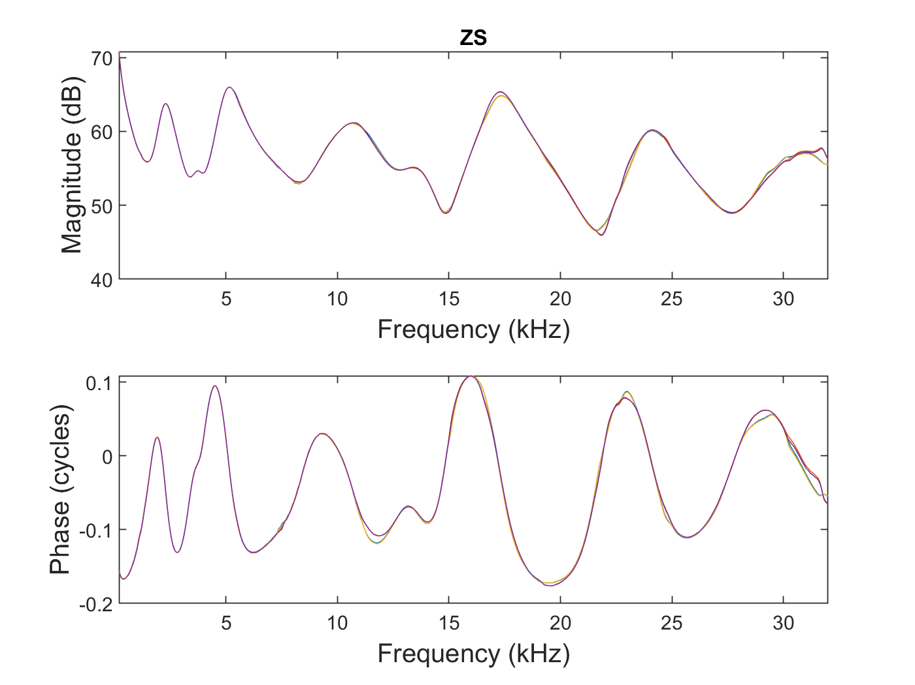

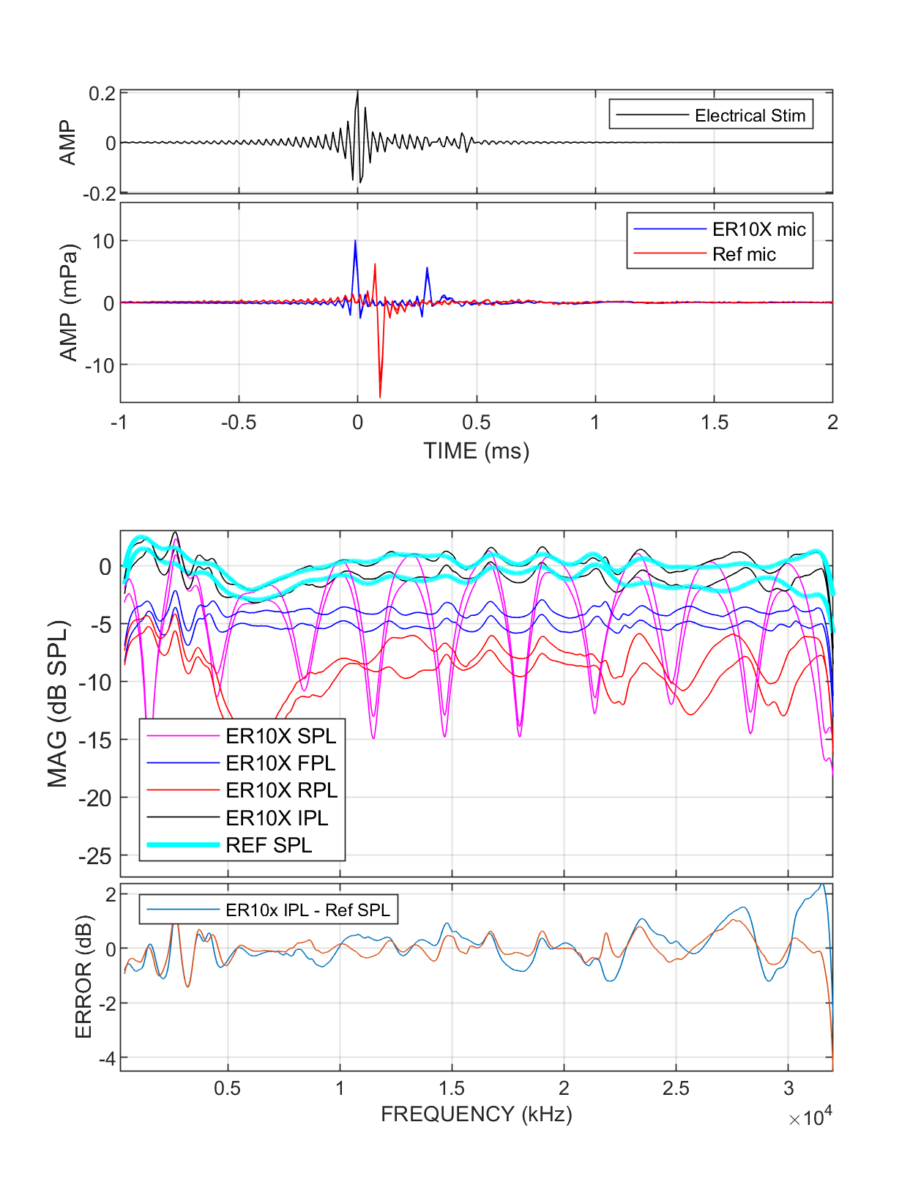

**Calibration Procedure: *2) in-situ***

**Troubleshooting**

**Discussion**

**FAQ**

**Q**: Are the exact lengths and/or numbers of Thevenin calibration tubes specified in this document necessary?

**A**: No; other number and length combinations can be used. Technically, only two tubes are needed in order to solve for the two unknown variables in the equations. However, in practice it is best to solve an over-determined set of equations. Practical experience has shown that 4-5 tubes works best. What is important is that the lengths of the tubes be chosen such that the quarter- and half-wave resonances of the different tubes do not overlap. As much separation as can be achieved is best. This is not a trivial problem once the calibration bandwidth becomes large. The lengths given in this document work well. I have failed to find any better combination of lengths, though they may exist.

Issues with different tips. In general, having a calibration tube the same size as the expected ear canal is important. You cannot go from the 0.8 human size down to the 3 mm rodent size and have it work. Can you go in the other direction though? Check!

**Acknowledgements**

Steven Neely proved generous collaboration for many years.

Kren

John Siegel

Doug Keefe

Sumit Dhar

Rob Withnell

**Contact**

Shawn S. Goodman, PhD

Director of the Auditory Research Lab

Dept. of Communication Sciences & Disorders

The University of Iowa

Iowa City, IA 52242

shawn-goodman@uiowa.edu

319-331-8761